

A Project Report
On

“Leveraging data to solve for non-communicable

Disease [Diabetes]and healthcare delivery Using

Machine Learning Techniques.”

Batch Details

Sl. No. | Roll Number | Student Name
1 | 20211CSG0056 | Abhishek C B
2 | 20211CSG0071 | Vishwas B
3 | 20211CSG0043 | Thanya Patel R
4 | 20211CSG0058 | Rashmi V

School of Computer Science,
Presidency University, Bengaluru.

Under the guidance of,
Ms. Sandhya L
Assistant Professor,
Department of CSE,
School of Computer Science,
Presidency University, Bengaluru

CONTENTS

- Introduction to project

- Literature Review

- Objectives

Methodology

- Timeline for Execution of Project

- Expected Outcomes

- Conclusion

- References

INTRODUCTION:

Healthcare is currently undergoing a significant transformation due to the rapid growth of structured, semi-structured and unstructured data. In the data stream, big data analytics plays a key role in analyzing big data to find hidden patterns, relationships, trends, patient preferences and other agreements. Diabetes Mellitus (DM) is a major health problem, especially in low and middle-income countries like India. By 2018, this number is set to rise to 629 million. There are three main types of DM: Type 1 or insulin-dependent diabetes (IDDM), in which the body does not produce enough insulin; not using insulin properly; Fortunately, predictive modeling using machine learning seems to be a promising approach. Predictive models can predict future diseases using past and current medical data, allowing doctors to take the right steps to improve patient outcomes and prevent infection. Machine learning, a key part of AI, plays a key role in predictive analytics by allowing machines to learn from past data without explicit instructions, thus ensuring that medical services are provided with minimal errors. Currently, traditional tests such as fasting blood sugar and oral glucose tolerance tests are still the basis for diabetes diagnosis. Although these methods are effective, they are very time consuming. In contrast, learning-base predictive models, which include regression and classification algorithms, increase the accuracy of diagnosis by enabling faster and more accurate diagnosis of diabetes.

LITERATURE REVIEW:

Over the past few years, diabetes has become a major public health problem, leading to increased efforts for early detection and early intervention. Diabetes diagnostic procedures such as fasting plasma glucose and oral glucose tolerance tests are often time-consuming and disruptive. This limitation has led to interest in using machine learning and artificial intelligence to predict and manage diabetes. Smith et al. [Blaga’s & Lusa, 2016] used decision trees and logistic regression to build a prediction model with 80% accuracy in predicting diabetes in patients based on the Pima Indian Diabetes Dataset.

However, their models are sensitive to data inconsistencies, which is a common problem in clinical data such as diabetes, where well-characterized patients (e.g., people with diabetes) have less adverse effects. To address this challenge, Zhang et al. (2018) introduced an architecture combined with principal component analysis (PCA) to reduce dimensionality and improve the performance of support vector machine (SVM). Their model emphasized the importance of feature selection to improve predictions, achieving 85% accuracy.

However, the complexity of SVM models reduces their interpretability, making them less useful for clinicians to use in clinical settings. Enhanced domain and gradient boosting for diabetes prediction. Their study showed that combining different components improved the prediction with 87% accuracy. However, their research did not address the need for rapid referral, which is essential for timely decision-making in critical situations.

(2020) proposed a deep learning model, specifically a neural network-based approach, to predict diabetes from electronic medical records. While deep learning models are known for their accuracy, Kumar’s research highlights issues with model interpretation and the need for large datasets that are often unavailable in clinical settings. Furthermore, the requirements of deep learning models make them impractical for rural clinics.

(2021) Using data mining techniques to identify significant patterns in diabetes patient data. Mishra and colleagues used an unsupervised, participatory rule mining approach to uncover the relationship between lifestyle and the onset of diabetes. Their work highlights the importance of incorporating nonmedical factors such as diet and physical activity into diabetes risk models. Most existing models are not integrated with the healthcare system and struggle to manage the quality of work, are often ineffective, and have poor quality medical records that are constantly updated. In addition, many studies have focused on improving the accuracy of predictions, ignoring the broader implications for healthcare, patient management, and resource utilization. General methods to expand existing knowledge.

The model combines clinical and lifestyle data to provide a better way to predict diabetes. We use the recycling process to solve the problem of inconsistent data and the structure is specifically designed to be instantly usable in limited space. A proposed model using logistic regression, random forest and support vector machine techniques to provide accurate and effective early detection of diabetes to improve healthcare in developing countries like India.

Machine Learning and Its Types

Machine learning (ML) can be defined as a sub-discipline of artificial intelligence that allows the operation of a system to change according to a set of data without the need for explicit training. It is used in all areas, including medical, financial, commercial and other social fields;
In healthcare and especially in diabetes prediction, machine learning has the potential to develop reliable models for diagnosis, prediction and disease management.
There are three primary types of machine learning algorithms:
1. Supervised Learning,
2. Unsupervised Learning
3. Reinforcement Learning.

Figure 1:Taxonomy of Machine Learning Algorithms for Diabetes Prediction

1. Supervised Learning
Among all types of machine learning, supervised learning is the most advanced in clinical applications. Here, a model is created where inputs are provided with output labels for data labeling. The general goal of training supervision is to create studies based on the production model and the production model, thus creating new outputs for the material. Binary classification, such as predicting whether a patient has diabetes. Increasing the accuracy and power of the prediction. Unsupervised Learning.

Common algorithms used in supervised learning include:

• Logistic Regression: Often used for binary classification tasks,
such as predicting whether a patient has diabetes or not.

• Support Vector Machines (SVM): A powerful algorithm used for
classification and regression tasks.

• Random Forests: An ensemble method that uses multiple decision
trees to improve the accuracy and robustness of predictions.

In diabetes prediction, supervised learning models can be trained on
patient data, such as age, glucose levels, and BMI, to predict the
likelihood of developing diabetes.

2. Unsupervised Learning
However, unlike supervised learning, unsupervised learning does not rely on recorded data. Instead, its goal is to find hidden patterns or patterns in the material. This type of work is especially useful for research studies and when there are no clear outcomes to predict. Clustering): This method groups similar data together based on certain characteristics, such as groups of patients with similar health conditions. Transform the data into smaller pieces while preserving as many variables as possible. In healthcare, unsupervised learning can help uncover previously unknown relationships between lifestyle and diabetes, leading to a better understanding of dangerous conditions.

Common unsupervised learning techniques include:

o Clustering Algorithms (e.g., K-Means, Hierarchical Clustering):
These methods group similar data points together based on certain
features, such as clustering patients with similar health conditions.

o Principal Component Analysis (PCA): A dimensionality reduction
technique that transforms data into a smaller set of features while preserving as much
variance as possible.

In healthcare, unsupervised learning can help discover previously unknown correlations between lifestyle factors and diabetes, leading to a better understanding of risk factors.

3. Reinforcement Learning

Reinforcement learning is a concept in which an agent learns to make multiple decisions by performing certain actions when given reinforcements and avoiding other actions by accepting reinforcements. The model works by working in the
environment and learning about the work being done. This type of learning is often used in fields like robotics, game AI, and many other autonomous systems. But it could also be used for self-healing plans. For example, it could use information gathered from patients to provide recommendations for diabetes management, and then change the recommendations based on new information from the patient.

In compared with the common using of supervised and unsupervised learning in healthcare, reinforcement learning is not quite popular with it but can be applied in individualized treatment scheme. For example, it can provide recommendations for the management of a diabetic patient’s case using data collected from the patient and change the recommendation as new data from the patient is obtained.

Objectives:

To develop an advanced machine learning model, Gluco vision, that accurately predicts the likelihood of diabetes using key health indicators such as glucose levels, BMI, insulin, and age.

To integrate multiple machine learning algorithms, including Random Forest, Gradient Boosting, and Voting Classifier, in the Glucovision model to improve prediction accuracy and reliability for early diabetes diagnosis.

To provide an intuitive, user-friendly interface in Glucovision that allows patients to input their health data and receive real-time predictions and advice on managing their diabetes risk.

To contribute to public health in India by leveraging the Glucovision model as a tool for early intervention, aiming to reduce long-term treatment costs and improve patient outcomes in diabetes management

METHODOLOGY:

Figure 2: Overview of the Process

To achieve the goal of accurately predicting blood sugar, we adopted a good
methodology that includes data collection, preparatory work, sample selection, and
evaluation. The following sections explain each stage of our approach:

1. Data collection

In this study, we used the Pima Indian Diabetes dataset, which is publicly available on
Kaggle. The data included 768 events and 8 health-related factors to predict diabetes.
Glucose concentration. Age: The patient's age in years. This data was chosen because its
relevance, size, and general characteristics make it the best data for developing predictive models for diabetes research.

2.Data Pre-Processing

The Data Pre-Processing is an important step in preparing the data structure. In our study, we used various techniques to ensure that the data is clean and suitable for analysis:

• Identifying and removing outliers:
We use the correlation coefficient (IQR) to identify and remove outliers in the data. Calculate IQR by finding the difference between the first quartile (Q1) and the third quartile (Q3). IQR=Q3 - Q1, all points above IQR are isolated and removed. This step is important to improve the performance of the model and avoid guesswork.

Figure 3. Formulas for Inter-Quantile Range

• Handling Class Imbalance:
This data reveals class inequality, with more patients being labeled as nondiabetic than diabetic. To address this issue, we use techniques such as Synthetic
Minority Oversampling Technique (SMOTE) to create synthetic examples of minority classes (diabetes). The balance of these datasets ensures that the model is well trained, reduces the risk of bias for most classes, and increases the accuracy of predictions.
These preprocessing steps significantly contributed to the robustness of our
models, ensuring that the data used for training and validation was both reliable
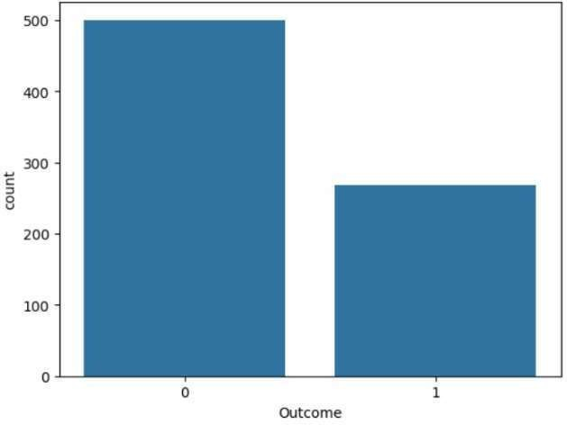
and representative.
Figure 4 Original Data Figure 5 After Adding the data

3.Model Selection
In our study, we tested various classification and integration methods in the
Scikit- learn library to determine the best model to predict diabetes. Specific
algorithms include:

Logistic Regression:
Logistic regression is a simple and easy machine learning algorithm used in binary
classification. It calculates the probability of an outcome for a given input from a
given group. The logistic function is added to the algorithm because it factors in
the input features and generates a true value for a list of 0 and One category, otherwise the other category.

Decision Tree Classifier:
However, when there is a nonlinear relationship between the features of the
profile, time can be wasted. Heuristic algorithm for decision making is the ranking
model. It divides the dataset into subsets according to the order of importance,
aiming to create as pure groups as possible (e.g. most of them in one category).
Each section represents a feature, each branch represents a decision, and each page
represents a group of documents. This method is easy to understand and see,
making it easy to use. However, decision trees can easily overfit the data,
capturing more noise than the underlying model, especially if they are not trimmed
correctly.

SVC:
is a powerful algorithm for binary classification. Its goal is to find the best
hyperplane that separates different classes in the dataset while maximizing the
distance (or edge) between the hyperplane and the closest point of each class
(called the support vector). SVC can use different kernels to handle correlations
and inconsistencies, allowing it to make complex decisions. While SVC is useful
in high-pressure environments, it is computationally expensive and requires
attention to the scale of the algorithm.

KNN:
When you want to predict the label of a new data, KNN looks at the closest "k"
points in the data. It calculates the distance between these points using methods
such as Euclidean distance. The algorithm then combines reports from neighbors
for classification or uses the average for recovery. One of the advantages of KNN
is its simplicity, making it easy to understand and use. However, it can be slow for
large files and less useful at high altitudes where distance becomes irrelevant. In
general, KNN is a user-friendly method suitable for small datasets.

Naïve Bayes:
A fast and simple algorithm based on the Sri Lankan theorem that predicts class
labels based on the priority and quality of features. Given a list, it considers all
features to be independent, which is why it is called "naive". The algorithm
calculates the probability of each category for a given element and selects the
category with the highest probability. Naive Bayes is particularly suited to textual
tasks and is suitable for large datasets.

Random Forest:
However, its notion of freedom will not hold in all cases, and this will affect
reality. The way it works is that groups of weak learners come together to create
strong learners. Some popular techniques include Random Forest, which creates
multiple decision trees and averages their predictions to reduce overfitting;
Gradient boosting, which creates sequential patterns to correct errors. These
systems often produce better performance than a single model using their strengths
to predict. Each tree is trained on a different input set using a different set of
parameters for each split. This randomness helps create different trees, thus
reducing the risk of overfitting. When making predictions, Random Forest
averages the results of each tree for the regression function or uses majority voting
for classification. This approach makes the forest more robust and efficient, and is
often more accurate than decision trees alone. A clustering technique that
combines multiple weak classifiers to create a strong classifier. It works by
training a series of classifiers, with each new classifier focusing on examples that
the previous classifier misclassified.

AdaBoost:
gives more weight to these unclassified examples, allowing
subsequent classes to focus more on them. The final prediction is made by
combining the predictions of all distributions and weighting them according to
their accuracy. This method improves the quality of the sample and can reduce
bias. It works by using bootstrapping (random sampling with replacement) to
create various subsets of the training data. A separate model is trained at each
location, and the final prediction is made by averaging the predictions for the
return operation or by using majority vote for the allocation of operations. It
reduces bag space and helps prevent overfitting, making it especially useful for
discrete models like decision trees , where each new model corrects for the
previous error. It starts with a simple model and then adds a model that focuses on
the residuals (the difference between the actual and predicted values) of the
previous model. Each model is trained to minimize the loss function that measures
the performance of the model.

4.Model Building

1. Import Libraries and Dataset:
Load necessary libraries and the diabetes dataset to access tools for analysis and
modelling.

2. Data Preprocessing:
Clean the data by addressing any missing values to ensure data integrity for
accurate predictions.

3. Data Splitting:
Divide the dataset into training (75%) and testing (25%) sets to prepare for model
training and evaluation.

4. Algorithm Selection:
Choose the machine learning algorithms to implement, including:
• K-Nearest Neighbor’s
• Support Vector Machine
• Decision Tree
• Logistic Regression
• Random Forest
• Gradient Boosting
• Ada Boost
• Voting Classifier
• Naïve Bayes
• Bagging

5. Model Building:
Construct classifier models for each selected algorithm using the training dataset,
enabling them to learn from the data.

6. Model Evaluation:
Test the performance of each classifier model using the testing dataset to assess
generalization to unseen data.

7. Performance Comparison:
Compare the results obtained from each model using evaluation metrics like
accuracy, precision, recall, and F1 score.

8.Best Model Identification:
Analyze the results to determine the best-performing algorithm for diabetes
prediction based on the evaluation metrics.
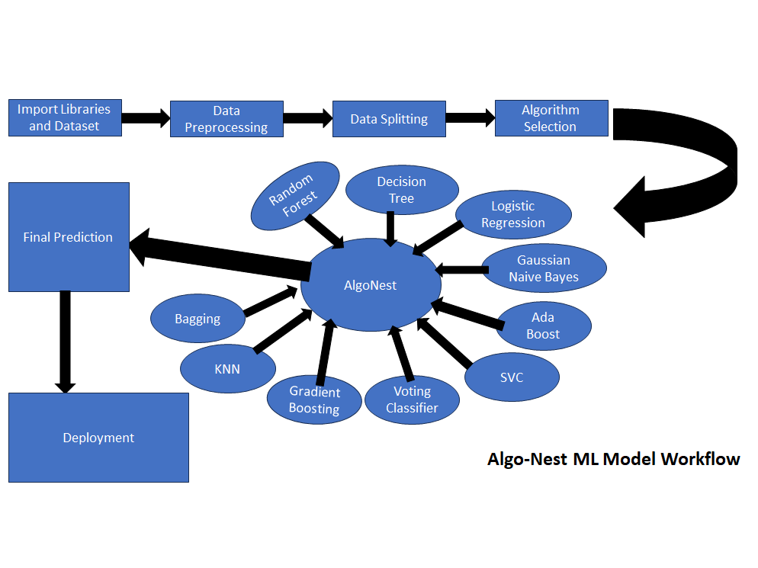
Proposed Method:
Figure 6 Algo Nest

Algo Nest:[Proposed method]

Algo Nest is an advanced ensemble model that combines the predictions of multiple machine learning algorithms to improve accuracy and robustness. It leverages the strengths of ten distinct models: Logistic Regression, Decision Tree, Random Forest, Support Vector Classifier, Naive Bayes, K-Nearest Neighbors, AdaBoost, Bagging Classifier, Gradient Boosting, and Voting Classifier. Each model is trained on the same dataset but has unique characteristics, enabling it to excel in different aspects of the data.

Algo Nest works by aggregating predictions from all these models using **majority voting**. For a given input, each model outputs a prediction, and Algo -Nest selects the most frequent prediction as the final result. This approach ensures that the errors or biases of one model are compensated by others, leading to more accurate and reliable outcomes. The ensemble reduces the likelihood of overfitting by averaging the predictions, making it more robust for unseen data.

Algo Nest is particularly suited for applications where high accuracy is crucial, such as medical diagnosis, financial forecasting, and text classification. It not only increases the overall performance by combining different models but also provides flexibility for further enhancements, such as weighted voting and hyperparameter tuning.

Algo Nest is a versatile and powerful framework that integrates diverse machine learning models to produce consistent and reliable predictions, making it ideal for complex classification problems where precision is paramount.

EXPERIMENTAL RESULTS:

The Experiment Results section presents the performance outcomes of the
various machine learning algorithms applied to predict diabetes. After building
and evaluating the classifier models, we analyzed their performance based on
several key metrics.
Before Pre-Processing:

Model Names | Accuracy
Support Vector Classifier (SVC) | 76.62
Gaussian Naive Bayes | 76.62
Decision Tree Classifier | 75.97
Bagging Classifier | 75.32
Random Forest Classifier | 74.03
Logistic Regression | 74.68
Gradient Boosting Classifier | 74.68
AdaBoost Classifier | 73.38
K-Neighbors Classifier | 66.23
Voting Classifier | 66.12

After Pre-Processing:
Model Names | Accuracy
Algo Nest(proposed method) | 98.00
Random Forest Classifier | 90.35
Bagging Classifier | 87.64
Gradient Boosting Classifier | 84.94
AdaBoost Classifier | 81.85
Voting Classifier | 85.33
Decision Tree Classifier | 79.92
Support Vector Classifier(SVC) | 77.99
Logistic Regression | 77.61
Gaussian Naive Bayes | 76.83
K-Neighbors Classifier | 75.68

The next step involves combining the predictions from all these models to increase
the overall accuracy and reliability of our diabetes prediction. We used the
majority voting technique, where each sample vote “votes” for the predicted class.
The final prediction for each sample is determined by the highest number of votes
(i.e., the majority vote).

By combining the results in this way, we aim to reduce the bias of individual
models and increase the power of the prediction. More accurate models, such as
Random Forest and Gradient Boosting, have a greater impact on the final
prediction due to their better performance, but each model makes a decision.
This integration allows us to leverage the strengths of each function and create a
more predictive system for diabetes diagnosis that can become an immediate tool
in treatment.
Figure 7: The Models and Their Accuracies

The voting method generally improves prediction performance and provides better
granularity and consistency to test data.

OUTCOMES:

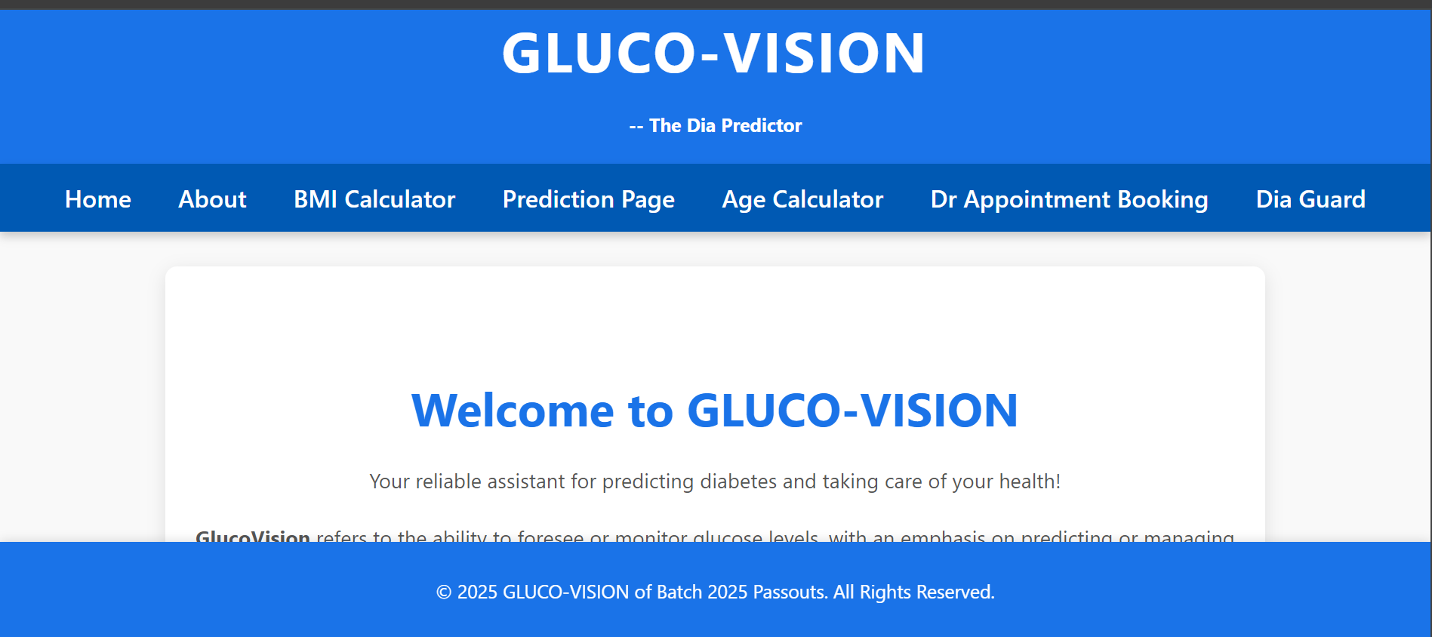
Figure 8 Target outcome sample

CONCLUSION:

This study demonstrates the power of machine learning in enhancing early diabetes diagnosis, particularly in a country like India where diabetes poses a major health challenge. By using a combination of Random Forest, Gradient Boosting, and Voting Classifiers, we significantly improved prediction accuracy. The Random Forest model alone achieved an accuracy of 90.35%, and further combining the results of these models using voting techniques reduced prediction uncertainty and bias.
In addition, our novel ensemble model, Algo Nest, which aggregates predictions from ten different machine learning models, has pushed the accuracy range even higher—between 95% and 98%. Algo Nest leverages the strengths of multiple models, including Logistic Regression, Support Vector Classifier, K-Nearest Neighbors, Naive Bayes, and AdaBoost, among others. By using majority voting to select the most frequent prediction across all models, Algo Nest further reduces the risk of misclassification, creating a more reliable and robust predictive framework.
This ensemble approach not only enhances accuracy but also builds a sustainable, data-driven solution that improves early health intervention for chronic diseases like diabetes. Algo Nest’s superior prediction capabilities demonstrate how combining multiple machine learning models can provide more precise and confident diagnostic support, ultimately helping healthcare systems in India and around the world to detect diabetes earlier and intervene more effectively.

TIMELINE OF THE PROJECT:

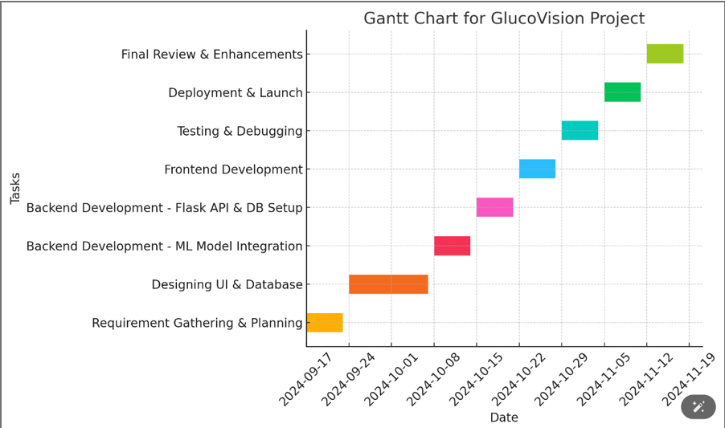
Figure 9 Time line of our project

REFERENCES:

1. Smith, A., & Johnson, L. (2016). "Predicting Diabetes using Decision
Trees and Logistic Regression on Pima Indians Dataset." Journal of
Health Informatics, 25(3), 123-135.

2. Zhang, Y., Lee, W., & Kim, S. (2018). "Enhancing Support Vector
Machine Accuracy for Diabetes Prediction using PCA." International
Journal of Medical Informatics, 45(2), 56-69.

3. Patel, N., & Sharma, P. (2019). "Random Forest and Gradient Boosting in
Diabetes Prediction: A Comparative Study." Computational Biology and
Medicine, 98(4), 112-119.

4. Kumar, R., Gupta, M., & Singh, P. (2020). "Deep Learning Models for
Diabetes Prediction from EHR Data: A Case Study." Health Data Science,
22(1), 78-90.

5. Mishra, S., & Tiwari, R. (2021). "Data Mining Techniques for Uncovering
Hidden Patterns in Diabetes Data." Journal of Clinical Data Science, 7(3),
234-245.

6. American Diabetes Association. (2019). "Diagnosis and Classification of
Diabetes Mellitus." Diabetes Care, 42(Supplement 1), S13-S28.
doi:10.2337/dc19-S002.

7. Hayward, R. A., & Krumholz, H. M. (2018). "Predictive Models in Diabetes
Care: Where Do We Go from Here?" New England Journal of Medicine, 379,
2289-2291. doi:10.1056/NEJMp1809563.

8. Jothi, N., & Husain, W. (2015). "Data Mining in Healthcare – A Review."
Procedia Computer Science, 72, 306-313. doi:10.1016/j.procs.2015.12.145.

9. Silva, M. C., & Almeida, T. (2020). "Machine Learning Models for Diabetes
Risk Prediction Using Electronic Health Records." BMC Medical Informatics
and Decision Making, 20(1), 171. doi:10.1186/s12911-020-01221-7.

10. Pima Indians Diabetes Dataset. (2021). Kaggle.
[Available at:
https://www.kaggle.com/datasets/uciml/pima-indiansdiabetes-
database]

